**Exercise 1**

The first exercise will be something we will do all together as a class using my computer

What we want is the following object to be printed on the page as

var daysofweek = [

'Monday',

'Tuesday',

'Wednesday',

'Thursday',

'Friday',

'Saturday',

'Sunday'

];

To

* Monday
* Tuesday
* Wednesday
* Thursday
* Friday
* Saturday
* Sunday

**Exercise 2:**

Copy the following code to an empty html file called Exercise2.html

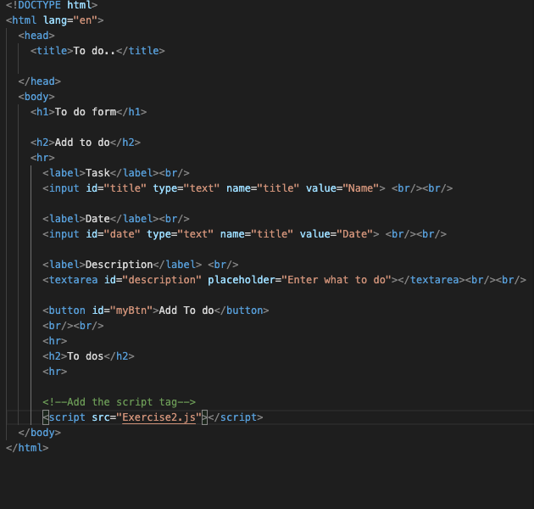

<!DOCTYPE html>

<html lang="en">

<head>

<title>To do..</title>

</head>

<body>

<h1>To do form</h1>

<h2>Add to do</h2>

<hr>

<label>Task</label><br/>

<input id="title" type="text" name="title" value="Name"> <br/><br/>

<label>Date</label><br/>

<input id="date" type="text" name="title" value="Date"> <br/><br/>

<label>Description</label> <br/>

<textarea id="description" placeholder="Enter what to do"></textarea><br/><br/>

<button id="myBtn">Add To do</button>

<br/><br/>

<hr>

<h2>To dos</h2>

<hr>

<!--Add the script tag-->

<script src="Exercise3.js"></script>

</body>

</html>

Create a JavaScript file called **Exercise2.js**

|  |
| --- |
| // We will write a code where the user can add a todo    // Step 1  // Create a function constructor called ToDo which takes a task, date, description    // Step 2  // Create another class called Board that has a property that is an empty array called tasks    // Step 3  // Extend the board through the prototype property and create  // addTask method that takes as input a todo  // it adds the todo to the tasks array property of the board    // Step 3  // Extend the board through the prototype property and create  // printTasks method that takes no input  // it prints on the console the tasks    // Step 4  // Instantiate a new object of Board    // Step 5  // Create two instances of Todo  // Initialise the first with task="go home", day="Tuesday"  // Intialise the second with task="make breakfast", day="Monday"    // Step 6  // Use the addTask method of the board to add todo1, and todo2    // Step 7  // Use the printTasks methodt of the board to display the tasks on the board    // Extras  // Try the same with the object.create(); |

The final result should look like this

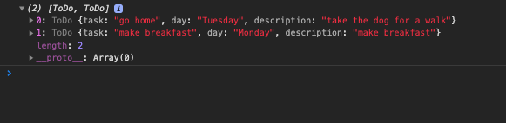

**Exercise 3:**

Continue from the previous exercise copy the html code and rename it to Exercise to Exercise3, change the script tag to Exercise3

Copy the following JavaScript code to Exercise3.js

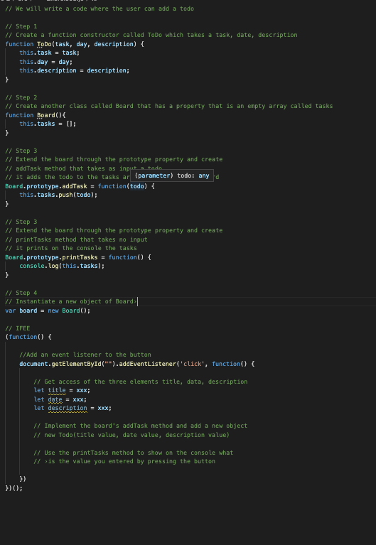

The result when you press the button should look like the following image

